

**Kingsgrove North High School**

**Mobile Phone Policy**

**Summary of Expectations**

**Our School’s Approach**

For the intent of this policy, the designation *'Mobile Phone*' encompasses mobile phones, smartwatches, earphones, headphones, and any analogous electronic devices capable of music playback or hosting applications or games.

### Rationale:

*Mobile Phones* have caused problems across the state and therefore the State Government has banned the use of these items within NSW Department of Education schools.

Kingsgrove North High School understands there are identified times to and from school when *Mobile Phones* are beneficial in communicating with parents/carers, but we also understand there are times when the use of *Mobile Phones* become problematic. This policy will be implemented effective from the first day of Term 4, 2023.

### Mobile Phone Rules:

*Mobile Phones* are to be OFF AND AWAY in bags when students are on school premises and at school events. This includes but is not limited to:

* Classrooms, outdoor classrooms, library
* Playgrounds (recess/lunch)
* Corridors
* Bathrooms
* Excursions and any school organised event

Prior to entering the school grounds, all *Mobile Phones* must be switched off and out of sight. Medical exemptions may apply through school approved application to the Principal.

**Purpose:**

*Mobile Phones* are problematic for the following reasons:

* They disrupt the learning environment.
* They invade privacy through the misuse of pictures/videos/voice recordings.
* They cause Issues related to cyber bullying (harassment, threatening, abuse, or embarrassment of students or staff).
* Prolonged use of *Mobile Phones* has proven to have a negative impact on one’s physical and/or mental health.

### Incorrect use of *Mobile Phone* procedures:

There will be zero tolerance for breaches of the Mobile Phone policy. Below are the actions that will be taken.

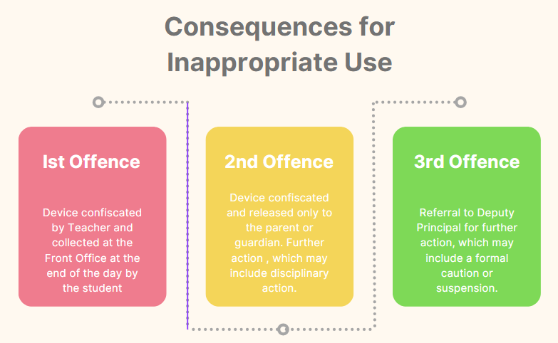

### Exemptions

An exemption from parts of this framework can be requested from the Principal by parents/ carers, school counsellors and other student support staff. Exemptions are for exceptional circumstances as deemed by the school Principal and may cover times when or places where use would otherwise be restricted. Except where required by law, the school Principal has discretion to consider and approve exemptions and to choose which parts of the school procedure the exemptions apply as determined by the exceptional circumstances. The exemption may be ongoing or for a certain period of time. A pass signed by the Principal will be issued to the student with the reasons and acceptable use of the device noted.

### Contact between students and parents/carers during the school day, and emergency contact.

Should a parent/caregiver need to contact a student at school because of an emergency, they are required to call the school’s front office and a message will be sent immediately to the student. If a student needs to make emergency contact with anyone, they can do so through the school’s front office. Contact between students and parents during the school day via the use of *Mobile Phones* will be deemed inappropriate use.

### Roles and Responsibilities:

**Students**

* Keep *Mobile Phones* out of sight, turned off or switched to silent (OFF AND AWAY). Devices need to be kept in bags (not in pockets). They are not to be visible or heard throughout the school day.
* Refrain from using *Mobile Phones* during the school day, including recess and lunch.
* Respectfully follow the instructions of staff and the rules of KNHS.
* Refrain from using *Mobile Phones* to contact parents, but instead contact parents via the school’s front office should an emergency arise.
* Organise a debit or credit card for any electronic payment through the Canteen or front office. Cash is also accepted.

### Teachers

* Enforce the Mobile Phone policy in every lesson, playground area, assembly, or any organised school event.
* Display appropriate signage supporting the Mobile Phone policy.
* Address policy violations or concerns to the Head Teacher or 2IC (Second in Charge)/delegate
* Use Sentral to record any issues to do with student misuse of Mobile Phones.

### Head Teachers and 2IC's:

* Enforce the Mobile Phone policy in every lesson, playground area, assembly, or any organised school event.
* Ensure staff know procedures and are aware of 2IC or alternatively arranged HT that they can contact.
* Support classroom teachers.
* Ensure faculty members are displaying signage for *Mobile Phone* use in the classroom.
* Attend classes to confiscate *Mobile Phones*, where students are not following the Mobile Phone policy.
* Use the issued envelope to seal *Mobile Phones* in when confiscated. Have student sign the envelope, HT sign the envelope, and the envelope with the *Mobile Phone* is kept in a safe place until it can be placed in the front office *Mobile Phone* locked cabinet before the end of the school day.
* Contact parent/guardian about inappropriate *Mobile Phone* use where necessary.

### Deputy Principals:

* Enforce the Mobile Phone policy at all times.
* Ensure faculties and staff are displaying signage for *Mobile Phone* use in the classroom and linked to Mobile Phone policy.
* Remind students about the Mobile Phone policy at assemblies, through the Parent Portal and social media platforms.
* Issue consequences where necessary, for breaches of the Mobile Phone policy.
* Liaise with parents/guardians about inappropriate *Mobile Phone* use, where necessary.
* Evaluate and review the Mobile Phone policy annually.

### Parents/Carers:

* Support KNHS Mobile Phone policy, including its approach to resolving issues.
* Remind their child/children about not using their *Mobile Phones* at school.
* Collect the confiscated *Mobile Phone* from the front office, where there has been more than one breach of the policy.
* Discuss safe and appropriate use of *Mobile Phones* with their child/children.
* Communicate with school staff and the school community respectfully and collaboratively as outlined in the 2018 School Community Charter ([https://education.nsw.gov.au/public-schools/going-to-a-public-school/school-](https://education.nsw.gov.au/public-schools/going-to-a-public-school/school-community-charter) [community-charter](https://education.nsw.gov.au/public-schools/going-to-a-public-school/school-community-charter)).
* Communicate with their child/children through the school’s front office should an emergency arise.
* Organise a debit or credit card for any electronic payment through the Canteen or front office. Cash is also accepted.

### Administration Staff:

* At the time a *Mobile Phone* is confiscated and presented to the office a SASS member will enter the data record on Sentral. If this is a repeated offence the DP will manage the situation.

### Evaluation: may be conducted annually, via (optional) meetings, Sentral data analysis, feedback from KNHS community and Walkthrough teams (Instructional Rounds).



**Kingsgrove North High School**

**Mobile Phones Policy**

**Student Agreement**

**PLEASE READ AND SIGN**

**Our School’s Approach**

### OFF AND AWAY

Phones are OFF AND AWAY during the school day. This message is reinforced by posters in each classroom. *Mobile Phones* will be confiscated by any teacher for students who fail to comply with this policy.

Students who wish to bring a *Mobile Phone* to school must read and sign this Student Agreement in the company of a parent or caregiver unless otherwise directed by the Principal.





**STUDENTS:** I agree that I will abide by the school’s Mobile Phone policy and that:

* *For the intent of this policy, the designation ‘Mobile Phone’ encompasses mobile phones, smartwatches, earphones, headphones, and any analogous electronic devices capable of music playback or hosting applications or games.*
* *Mobile Phones* are to be out-of-sight, turned off or switched to silent, OFF AND AWAY and need to be kept in bags. They are not to be visible or heard during the school day.
* If a teacher sights or hears the *Mobile Phone*, I will lose it.
* *Mobile Phones* will **NOT** be used in any aspect of the school day.
* I must respect and follow school expectations and procedures following the decisions made by staff at all times.

### PARENT/CAREGIVER:

I understand that my child will be responsible for abiding by Kingsgrove North High School's:

* Mobile Phone policy (OFF AND AWAY at all times)
* I have read and discussed the school’s *Mobile Phone* approach with my child and understand the responsibility they have in the use of their M*obile Phone*.

Date:

in the presence of (Print Student Name) (Print Parent/Caregiver Name)

Student Signature Parent/Caregiver Signature

Deputy Principal Name Deputy Principal Signature

## Use of Mobile Phones and Devices at school



**If we see or hear it, you lose it.**

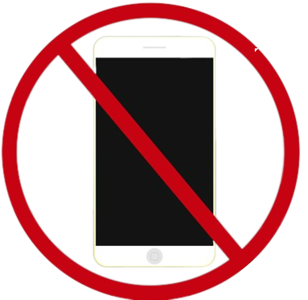

**Acceptable and Responsible Use**